Articles

**https://doi.org/10.1038/s41564-019-0361-5**

**Consistent trade-offs in fungal trait expression across broad spatial scales**

**Daniel S. Maynard****[1],2*, Mark A. Bradford****2, Kristofer R. Covey3, Daniel Lindner4, Jessie Glaeser4, Douglas A. Talbert5, Paul Joshua Tinker5, Donald M. Walker6 and Thomas W. Crowther7**

**Fungi are the primary agents of terrestrial decomposition, yet our understanding of fungal biogeography lags far behind that of plants, animals and bacteria. Here, we use a trait-based approach to quantify the niches of 23 species of basidiomycete wood decay fungi from across North America, and explore the linkages among functional trait expression, climate and phylogeny. Our analysis reveals a fundamental trade-off between abiotic stress tolerance and competitive ability, whereby fungi with wide thermal and moisture niches exhibit lower displacement ability. The magnitude of this dominance-tolerance trade-off is partially related to the environmental conditions under which the fungi were collected, with thermal niche traits exhibiting the strongest climate relationships. Nevertheless, moisture and thermal dominance-tolerance patterns exhibited contrasting phylogenetic signals, suggesting that these trends are influenced by a combination of niche sorting along taxonomic lines in tandem with acclimation and adaptation at the level of the individual. Collectively, our work reveals key insight into the life history strategies of saprotrophic fungi, demonstrating consistent trait trade-offs across broad spatial scales.**

F

ungi are prominent components of terrestrial ecosystems in terms of biomass and diversity, and they influence almost every aspect of terrestrial ecosystem functioning1,2. They are the dominant decomposers of organic plant material, with direct consequences for global carbon and nutrient dynamics3. Given that different fungi process organic matter at vastly different rates, the composition of fungi in an area can provide a tangible link between biological communities and the functioning of ecosystems1,2,4. Incorporating information about fungal communities into global biogeochemical models requires an understanding of fungal functional biogeography at broad spatial scales. Although molecular sequencing approaches can provide unrivalled insight into the taxonomic structure of microbial communities, they currently provide coarse insights into the functional potential of organisms. As such, we still have a relatively rudimentary understanding of the processes that give rise to broadscale biogeographical patterns in decomposer communities.

The composition of fungal communities is driven in part by climate and edaphic characteristics5,6, which can strongly affect local-scale fungal patterns7–9. Yet these niche processes appear to deteriorate at larger scales, with neutral processes (for example, dispersal limitation) often emerging as dominant drivers of broadscale taxonomic patterns5,6,10–12. The lack of evidence for broadscale niche patterns may be somewhat due to a focus on the taxonomic identity of isolates (as a by-product of molecular sequencing), rather than functional trait expression at the level of the individual2. Yet, the selective pressures imposed by different environmental filters act directly on traits, rather than taxonomic identity, and so it is expected that traits should reflect biogeographic patterns more closely than taxa per se2. It has been proposed that such traitbased exploration of fungal distributions can provide key insights into the functional biogeography of fungi2,13,14, facilitating a spatially explicit understanding of their functional roles in ecosystems worldwide.

In this study, we used a standardized approach to quantify tradeoffs in trait expression, competitive ability and niche characteristics in fungi collected from across a broad spatial extent. Specifically, we measured the expression of 17 functional trait groupings (Table 1), encompassing 124 unique trait measurements, in 23 unique species (37 isolates) of basidiomycete fungi collected throughout North America (from Alaska to Puerto Rico; see refs. 15,16) (Fig. 1a,b). We focused on saprotrophic wood decomposer fungi, all of which were collected from fruiting bodies in a

similar successional stage, ensuring that we compared trait variation in functionally equivalent fungi15–17. We chose a study design that provided a range of within-species and among-species variation in trait expression, with 7 of the 23 species containing a ‘north’ and ‘south’ isolate (Fig. 1, Supplementary Table 1), and with one species (*Armillaria gallica*) containing 4 ‘north’ and 4 ‘south’ isolates. Of course, these fungi represent only a tiny fraction of the taxa that dominate woody debris at this scale, but this design was selected because it comprises a feasible model system to quantify the expression of >100 functional traits while retaining sufficient power to explore any underlying trends.

We focused primarily on the expression of ecological performance traits (niche traits and competitive ability) that relate directly to the ability of an organism to survive in a given environment14. As a secondary focus, we explored various morphological and biochemical traits that underpin different metabolic pathways and resource requirements (Table 1). All traits were assayed under controlled laboratory conditions, allowing only a single environmental factor to vary at a time (see Methods), so as to disentangle the effects of abiotic stress on growth and trait expression18. Using these traits, we first quantified trade-offs in trait expression, indicating different

|  |  |  |  |
| --- | --- | --- | --- |
|  | **Table 1 | Set of functional traits measured on each fungal isolate** | |  |
| **Trait** | **Description** |
|  | **Physiological growth traits**  Hyphal extension rate | mm day−1 |  |
|  | Hyphal density | μg biomass cm−2 |  |
|  | **ecological performance traits** Thermal niche width | Range (°C) where extension rate ≥ 50% of maximum rate |  |
|  | Thermal niche maximum | Upper bound (°C) of thermal niche width |  |
|  | Thermal niche minimum | Lower bound (°C) of thermal niche width |  |
|  | Optimal temperature | °C at maximum growth rate |  |
|  | Moisture niche width | Range (MPa) where extension rate ≥ 50% of maximum rate |  |
|  | Moisture niche maximum | Upper bound (MPa) of moisture niche width |  |
|  | Moisture niche minimum | Lower bound (MPa) of moisture niche width |  |
|  | Optimal moisture | MPa at maximum growth rate |  |
|  | Displacement ability | Competitive rank (scaled) across all pairwise competitions |  |
|  | **Biochemical traits**  Hydrolytic enzymes | Production rate (per 7 d) for each of five enzymes |  |
|  | Oxidative enzymes | Production rate (per 7 d) for each of three enzymes |  |
|  | VOCs | Production rate (per 48 h) for each of 103 VOCs |  |
|  | **Dominance-tolerance trade-offs**  Thermal trade-off | Displacement ability − thermal niche width (scaled) |  |
|  | Moisture trade-off | Displacement ability − moisture niche width (scaled) |  |
|  | Combined trade-off | Displacement ability − (thermal niche width × moisture niche width) (scaled) |  |
| A total of 17 trait categories were measured under optimal laboratory conditions, totalling > 100 unique trait values per fungus. These trait groupings were broadly categorized into physiological growth traits, ecological performance (or niche) traits, biochemical traits and dominancetolerance trade-offs. VOCs, volatile organic compounds. | |

niche preferences or life history strategies. We then explored whether trait expression is linked to the local climate conditions from which the fungi were cultured, providing preliminary insight into fungal life history strategies across broad spatial extents. Lastly, we explored if any relationships persist after accounting for phylogenetic relatedness, to test if these patterns better reflect broadscale sorting of species at the taxonomic level, or individual-level and local-scale processes (for example, acclimation19).

# Results and discussion

**Trade-offs among fungal functional traits.** By modelling the niche space of each fungal isolate when growing along gradients of temperature and moisture, we generated individual-level estimates of ecological performance traits, including thermal and moisture niche optimum, maximum, minimum and width (Table 1 and Fig. 1). In contrast to many ecological communities20, there was relatively minimal variation in thermal and moisture niche optima (that is, conditions where extension rate is maximal), with the moisture optima falling between −1.0 and −0.2 MPa for all fungi (Fig. 1c–e), and temperature optima falling between 22 and 32 °C for all but five of the isolates (Fig. 1d,f). Only the *A. gallica* isolates exhibited a significantly lower moisture optimum relative to the average (−0.78 versus −0.47 MPa; Supplementary Table 2), with no other multi-isolate species showing consistent differences in temperature optima (Supplementary Table 2). Thus, despite being collected from vastly differing climate conditions—ranging from Alaska to Puerto Rico—all fungi shared approximately equivalent niche optima, preferring warm (~28 °C) and moist (~−0.5 MPa) conditions. These results suggest that the sorting mechanisms underpinning fungal life history strategies are not easily attributed to differences in the optimal growing conditions for each fungus.

Although optimal conditions were largely uninformative of species’ locations, there was substantial variation in species’ niche widths—calculated as the range for which the extension rate was ≥50% of their maximum rate14 (Table 1)—with fungi varying substantially in their capacity to tolerate cold and/or dry conditions (Fig. 1e,f). These overlapping niche optima but divergent stress tolerances are suggestive of trade-offs between abiotic stress tolerance and other ecological performance characteristics2,14. In support of this inference, we found that moisture niche width was negatively correlated with extension rate and competitive ranking (Kendall’s *τ* = −0.43, *P* = 0.002 and *τ* = −0.27, *P* = 0.04, respectively; Fig. 2). Conversely, extension rate was positively correlated with competitive ranking (*τ* = 0.55, *P* = 0.00003) and negatively correlated with density (*τ* = −0.28, *P* = 0.002). These initial pairwise trait relationships suggest clear differences in life history strategies, with fungi that have slow extension rates also having higher densities, wider niche widths and lower competitive abilities. Conversely, fastgrowing fungi are more competitive, albeit able to survive under a smaller range of environmental conditions.

To examine the importance of these trade-offs among growth strategies, competitive ability and stress tolerance, we identified the main independent dimensions of trait variation using a principal component analysis (PCA) applied to the full complex of functional traits (Fig. 3). The dominant trait PCA axis—which explained 22% of the variation in trait expression across all fungi—illustrates that individuals expressing traits associated with high competitive ability and rapid space acquisition were distinct from those expressing traits associated with thermal or moisture stress tolerance (Fig. 3). This trade-off in biomass allocation has been reported regularly throughout the fungal ecology literature21–23, where it has been linked to various foraging and competitive strategies21,22. Our data suggest that these trade-offs also appear to hold across broad spatial scales. Indeed, the ‘environmental stress response’ is a broadly conserved fungal gene expression response that provides a genetic basis for this trade-off 2,24, where the activation of ~300 genes that protect against harsh abiotic conditions coincides with the repression of ~600 genes associated with growth and physiological activity. The correlations observed in this study support the importance of this genetic mechanism in dictating functional trait patterns across fungi, suggesting that a dominance-tolerance trade-off is a key driver of life history strategies in wood decay fungi.

Biochemical traits were the dominant drivers of PC2 (Fig. 3), explaining an additional 11% of the variation in trait expression. In particular, the production of tetrahydrofuran (V1), 2-pentylfuran (V2), 2-butanone (V3), fenchone (V8), phenoloxidase and peroxidase were the dominant traits along the second axis of variation. The production of volatile organic compounds (VOCs) can be driven by resource-mediated decomposition of organic material25, or by interspecific interactions among fungi26. Similarly, phenoloxidase and peroxidase contribute to lignin degradation, but can also be upregulated during combative interactions27. Because substrate conditions vary substantially during the decay process, these different

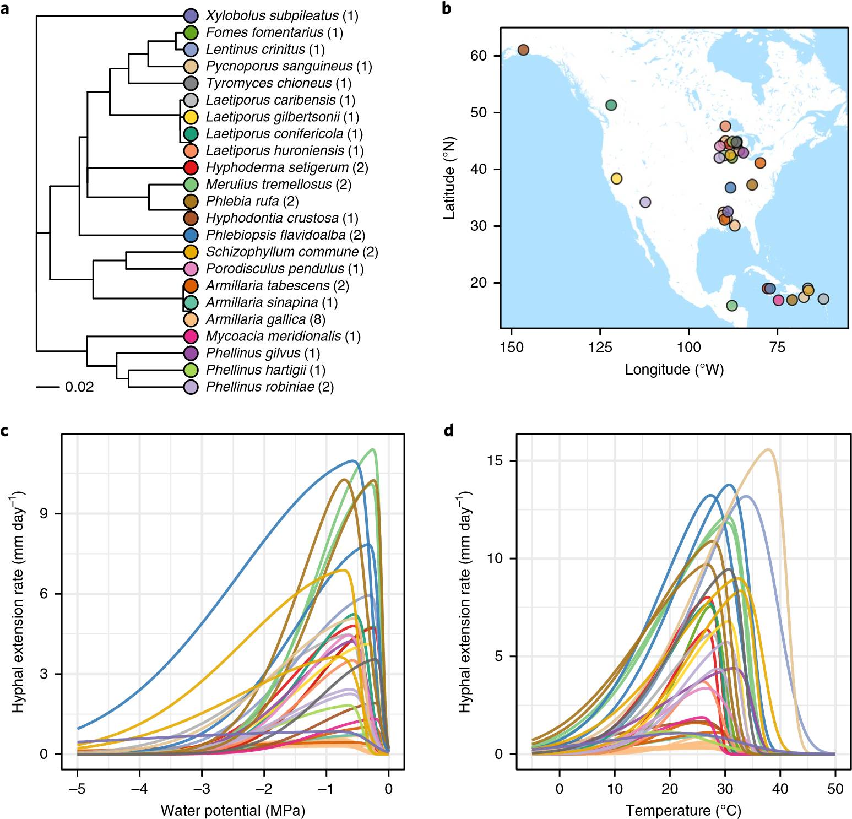

**e f**

2

3

4

5

–0.8

–0.6

–0.4

–0.2

Optimal moisture (MPa)

Moisture niche width (MPa)

10

15

20

25

20

25

30

35

Optimal temperature (°C)

Thermal niche width (°C)

**Fig. 1 |** **Fungal isolates and their niches.** **a**, Phylogenetic lineage of 23 fungal species comprising 37 unique isolates, with 8 species containing 2 or more isolates collected from different locations (the number of corresponding isolates per species is shown in parenthesis). **b**, Collection sites for the 37 fungal isolates, with fungi collected from Alaska to Puerto Rico (see Supplementary Table 1 for the exact latitude and longitude values). **c**, Moisture growth curves averaged across five moisture conditions (replicated 3 times each) for each of the 37 biologically independent fungal isolates. **d**, Temperature growth curves averaged across six temperatures (replicated 5 times each) for each of the 37 biologically independent fungal isolates.

**e**, Plots of optimal moisture versus moisture niche width. **f**, Optimal temperature versus thermal niche width. The species’ colours in **a** are used to denote the corresponding isolates in **b**–**f**.

resource requirements and competitive strategies are key drivers of variation suggests resource-mediated and biochemical trade-offs successional dynamics in fungi8,28. Thus, whereas PCA1 suggests that may relate to local habitat preferences, or perhaps dictate sucbroadscale trade-offs related to climate, this second axis of trait cessional dynamics in wood decay communities over time8,29.

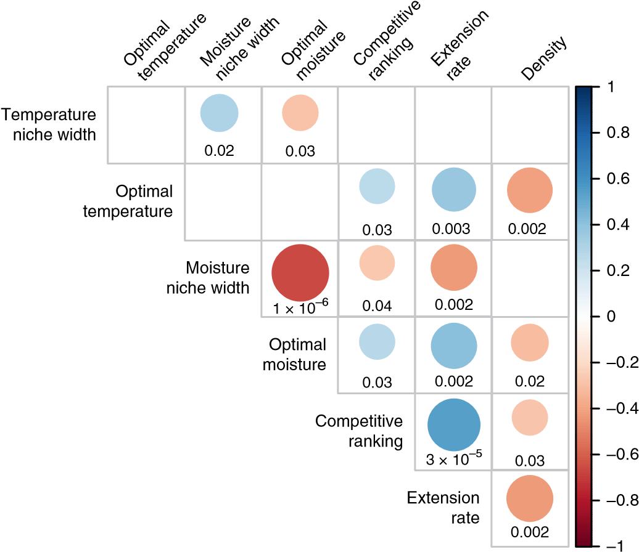

**Fig. 2 |** **Correlations between niche traits, physiological growth traits and performance traits.** Kendall rank correlation coefficients significant (*P* < 0.05, two-sided) after adjusting for multiple comparisons using Benjamini–Hochberg (*n* = 37) biologically independent isolates for each pairwise test. The size/colour of each circle denotes the correlation; the number below each circle gives the corresponding *P* value.

**The dominance-tolerance trade-off and climate.** We next explored the extent to which niche characteristics were linked to the underlying climate conditions under which each fungus was cultured, providing a preliminary insight into broad spatial patterns in fungal life history trade-offs. Using a standard regression approach (see Methods), we found that climate conditions had negligible relationships with the individual physiological traits when measured in isolation: climate PCA variables could not predict the variation in competitive ability nor moisture niche width, and showed a marginally significant relationship with thermal niche width (*F*3,32 = 2.84, *P* = 0.05; Supplementary Tables 4–5). However, when we calculated the difference between completive ability and niche width (defining the ‘dominance-tolerance trade-off’; Table 1), we observed strong and consistent relationships with climate variables. The three climate PCA variables explain 16% of the variation in the moisture dominance-tolerance trade-off, 30% of the thermal trade-off and 22% of the combined moisture × thermal trade-off (Table 2 and Supplementary Table 5). The temperature and moisture trade-offs yielded near-identical coefficient estimates, highlighting the close alignment between moisture and thermal niche width.

Climate PCA1 was a consistent positive predictor of high dominance and low niche width, with a standardized coefficient ranging from *β* = 0.157 to *β* = 0.196 across all three models (Table 2 and Fig. 4a). This PCA variable is positively correlated with the mean temperature of the wettest quarter and the mean precipitation of the warmest quarter (Supplementary Table 3), suggesting that regions with relatively warm rainy seasons select for fungi with low stress tolerance and high competitive ability. This result is presumably due to lack of hot, dry conditions and hence minimal need to invest in strategies to prevent moisture loss (for example, the production of heat shock proteins, osmolytes, or hydrophobic cell wall compounds2). Climate PCA2 and PCA3 each correlate significantly with temperature seasonality and temperature annual range, such that fungi occurring in climates with variable temperature regimes are predicted to have higher thermal niche widths and

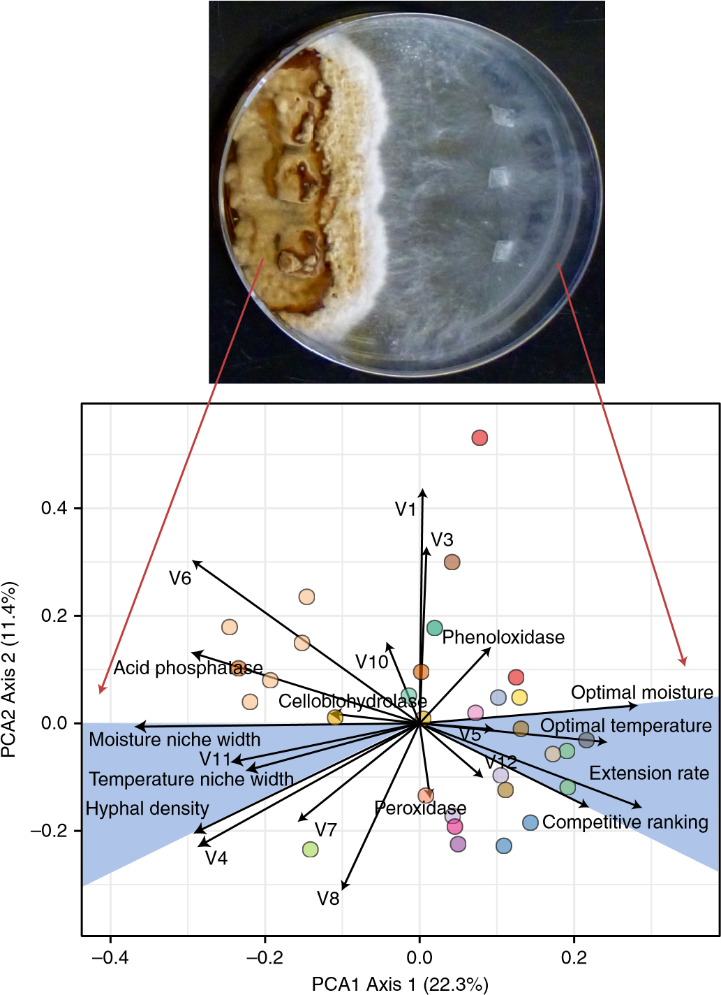

**Fig. 3 |** **PCA analysis provides evidence of a dominance-tolerance tradeoff in trait space.** PCA1 shows a clear distinction between fungi with high moisture and temperature optima, high extension rate and high competitive ability (for example, *Phlebiopsis flavidoalba*, right fungus) versus those with wide moisture and thermal niches and high density (for example, *Phellinus hartigii*, left fungus). PCA2 predominantly reflects differences in enzymes and VOC production. Note the clustering of several of the *A. gallica* isolates (tan) in the upper left quadrant, suggesting low within-species trait variation for this species. Colours correspond to the species in Fig. 1a (*n* = 32 biologically independent isolates for the PCA analysis).

lower dominance-tolerance values (Supplementary Table 3 and Supplementary Fig. 2).

**Phylogenetic relatedness and the dominance-tolerance tradeoff.** Using PGLS regression to simultaneously estimate the climate and the phylogenetic signals30, we consistently find that the thermal dominance-tolerance trade-off has a relatively weak phylogenetic signal. In contrast, moisture niche width and competitive ranking showed strong phylogenetic conservatism (Supplementary Table 6), such that the moisture trade-off and the combined thermal × moisture trade-off likewise show a significant phylogenetic signal. Thus, whether or not a fungus can withstand stressful precipitation climate patterns is more closely linked to its phylogenetic history, suggestive of precipitation-mediated spatial sorting of fungi along phylogenetic lines. This phylogenetic signal weakens the overall importance of climate per se as a predictor of spatial patterns (Table 2, coefficients in parentheses). The contrasting phylogenetic and climate patterns between thermal and moisture niche traits may be further compounded by the fact that fine-scale moisture conditions are typically an order of magnitude more variable than temperature within a region31,32, such that broadscale precipitation regimes may have little impact on fungal survival in temperate forests. A consistent relationship between moisture niche traits and climate may therefore only manifest in more extreme environments not considered in this study (for example, desert or aquatic fungi).

Determining whether these preliminary patterns are driven by habitat filtering at the taxonomic level or by local-scale adaptation and acclimation at the individual level remains challenging. The inclusion of fungi across broad phylogenetic lineages and from disparate environmental conditions is ultimately needed so as to fully constrain the observed relationships and gain increased spatial resolution. Yet our results suggest two possible hypotheses for the relationships among climate, trait expression and phylogeny. On the one hand, the fact that thermal traits are weakly influenced by phylogeny aligns with the expectation that some fungi can acclimate or adapt to temperature conditions over a relatively short time19,33, such that the location of a fungus may ultimately dictate its thermal trait expression and not vice versa. On the other hand, despite a weak phylogenetic signal, there was significant clustering of niche traits within species (for example, *A. gallica*, light tan points and lines, Figs. 1 and 3) demonstrating that fungi are not completely plastic in their trait expression. Indeed, taxonomic identity was significantly correlated with the dominancetolerance trade-offs (Supplementary Table 2) with *A. gallica* and *Phlebia rufa*, in particular, each accounting for at least 15% of the variation in each outcome.

Our results suggest that the observed spatial patterns are driven by a combination of taxonomic sorting at the species level, partly because of phylogenetically conserved traits (primarily competitive ability and moisture niche width), in tandem with local-scale processes, such as thermal acclimation or adaptation, which may alter the trait expression of a fungus. Nevertheless, we reiterate that a significant amount of variation remains unexplained by climate and phylogenetic factors (circa 70%), even after accounting for species-specific effects. Thus, the dominance-tolerance tradeoff is likely just one of the many factors contributing to the broadscale biogeography of fungi; other important drivers likely remain to be identified.

|  |  |  |  |  |  |
| --- | --- | --- | --- | --- | --- |
|  | **Table 2 | Relationship between climate and dominance-tolerance trade-offs** | | |  |  |
|  | **Thermal**×**moisture dominance-tolerance** | **Thermal dominance-tolerance** | **Moisture dominance-tolerance** |
| Climate PCA1 | 0.196 (0.143) | 0.196 (0.187) | 0.157 (0.098) |
|  |  | (0.10–0.30) | (0.10–0.30) | (0.04–0.27) |  |
|  |  | *P* = 0.004 | *P* = 0.004 | *P* = 0.05 |  |
|  | Climate PCA2 | −0.027 (−0.025) | −0.096 (−0.066) | −0.020 (−0.010) |  |
|  |  | (−0.10–0.04) | (−0.17 to −0.03) | (−0.10–0.06) |  |
|  |  | *P* = 0.63 | *P* = 0.05 | *P* = 0.67 |  |
|  | Climate PCA3 | −0.082 (−0.027) | −0.024 (−0.012) | −0.079 (−0.025) |  |
|  |  | (−0.15 to −0.01) | (−0.09–0.04) | (−0.16–0.00) |  |
|  |  | *P* = 0.07 | *P* = 0.63 | *P* = 0.15 |  |
|  | *R*adj2 | 0.22 | 0.30 | 0.16 |  |
|  | *F* (d.f. = 3, 29) | 7.10 (*P* = 0.001) | 9.4 (*P* = 0.002) | 3.66 (*P* = 0.02) |  |
|  | AIC | −1.51 | −2.13 | 10.59 |  |
|  | Pagel’s *λ* | 0.68 | 0.39 | 0.66 |  |
|  | LRT *λ* = 0 | *χ*2 = 12.7 (*P* = 0.0004) | *χ*2 = 4.1 (*P* = 0.043) | *χ*2 = 15.1 (*P* = 0.0001) |  |
|  | AIC (PGLS) | 17.9 | 15.8 | 26.9 |  |
| Climate PCA1 emerged as a strong, consistent predictor of the trade-off, with the thermal trade-off having the highest predictive power. Coefficients were estimated using standard linear regression, with two-sided *P* values calculated using the standard normal approximation and adjusted for multiple comparisons using the Benjamini–Hochberg method. The values in brackets give the 95% confidence interval for the effect size; the coefficients in parentheses give the corresponding effect size using PGLS regression (*n* = 37 biologically independent isolates for all tests). AIC, Akaike information criterion; LRT, likelihood ratio test. | | | |

**The dominance-tolerance trade-off at a regional scale.** We applied these regression trends to climate data across North America, providing an initial spatial characterization of the dominance-tolerance trade-off (Fig. 4; see Methods). We focused on the thermal trade-off because it aligns closest with climate variables (Table 2), yet all three dominance-tolerance metrics exhibit nearly identical spatial patterns (Supplementary Fig. 1). We only provide estimates for regions whose climate variables fell within the observed climate range across the fungi (see Methods); we focused on the eastern USA, since this region encompasses the majority of the fungi we measured (Fig. 1).

This visualization (Fig. 4) shows that subtropical fungi are predicted to have the highest dominance-tolerance values because of high competitive ability and small thermal niche width (Supplementary Fig. 2). Northerly fungi are estimated to have lower competitive abilities than subtropical fungi; yet because they have relatively low stress tolerance, they likewise have correspondingly high dominance-tolerance values, highlighting that this trade-off is calculated as the net difference between competitive ability and stress tolerance. These relationships lead to a ‘U’-shaped pattern in the dominance- tolerance trade-off (Table 1), with fungi from the southern USA (for example, several of the *A. gallica* isolates; Fig. 1) having the lowest dominance-tolerance values driven by high stress tolerance and low competitive ability (Supplementary Fig. 2).

These results provide baseline insight into broadscale niche patterns in fungi. We reiterate that such patterns are still preliminary, partly because of the relatively small sample size used in this study. Substantial additional data are needed to obtain the necessary precision and accuracy to translate these spatial patterns into detailed biogeographical inference. A crucial next step in improving the resolution and accuracy of the detected relationships is to explore these patterns under a greater array of environmental contexts and across a broader contingent of fungi. For example, we only quantified competitive ability under a single environmental condition (22 °C, −0.5 MPa). Whether or not these competitive outcomes vary across abiotic contexts may elucidate additional environmental axes and physiological trade-offs not considered in this study. Similarly, we only measured hyphal extension rate between 10 and 40 °C. Understanding how fungi respond to more stressful environmental

|  |
| --- |
| **a b**  **Fig. 4 |** **Visualizing the dominance-tolerance trade-off across broad spatial scales.** **a**, Partial regression plot for PCA1 versus the thermal dominancetolerance trade-off, with the solid line denoting the mean regression trend and the shaded region denoting the 95% confidence interval for the mean (*n* = 37 biologically independent isolates). **b**, The regression trends in **a** mapped onto regional climate variables. Purple represents high dominancetolerance values; yellow represents low values. Pixels whose climate values fell outside the range of the observed values or which were not classified as |

forested biomes were excluded and are coloured white (see Methods).

conditions—such as periodic freeze–thaw cycles or long-term subzero temperatures—may provide an important additional insight into broadscale life history trade-offs. Indeed, survival in a specific environment requires that a fungus not only maintains a positive extension rate, but also has sufficient energy to reproduce and disperse to new microhabitats. Although we focused on dominancetolerance trade-offs, these competition–colonization trade-offs are a key aspect of life history strategies across organisms (for example, Grime’s C-S-R triangle theory34), with particular importance given to local-scale successional patterns in wood decay fungi2,8. Understanding how reproductive traits modify the observed dominance-tolerance pattern is a particularly compelling open question, and one whose answer would help to contextualize these results within the broader field of niche theory.

# Conclusions

Our work provides evidence that functional trait trade-offs reflect broadscale life history strategies in saprotrophic fungi. The fungi exhibited a clear dominance-tolerance trade-off between competitive ability and stress tolerance that is partially linked to the environmental conditions under which the fungi were collected. Although the exact drivers of this relationship between trait expression and climate remain to be elucidated, our work suggests consistent life history trade-offs at broad spatial scales. Expanding the use of such trait-based approaches to a wider range of fungal taxa, and using emerging statistical and genetic tools, is necessary if we are to ultimately generate predictable biogeographic patterns. By demonstrating that saprotrophic fungi exhibit dominance-tolerance trade-offs at broad spatial scales, these results enhance our ecological understanding of these functionally important organisms.

# Methods

**Fungal isolates.** Fungi were obtained from the Center for Forest Mycology Research (CFMR) at the Forest Products Laboratory, Madison, WI, USA. Fungi were originally collected from fruiting bodies throughout North America (Fig. 1) and stored in liquid nitrogen at CFMR since the time of collection, without serial transfer at any point. Throughout the experiments, fungi were stored in the dark in incubators at 22 °C (unless otherwise noted) on 2% malt extract agar (MEA) Petri dishes, sealed with Petri-Seal (Diversified Biotech). Between experiments, stock cultures were kept at 2 °C on 2% MEA in 50 mL centrifuge tubes for long-term storage. Experimental replicates were taken from these stock cultures to minimize replating. The original cultures are still housed at CFMR.

**Trait measurements.** The direct measurement and comparison of fungal traits necessitate the use of growing conditions that exert similar selective pressures on all fungal species. Every natural growing environment exerts a range of stresses, the effects of which vary across different fungal species. Removing these stresses is essential to generate standardized conditions that are equivalent for all fungal isolates. Therefore, we followed trait-based approaches in plant ecology35 by measuring potential trait expression under ‘optimal’ growing conditions18. All assays were conducted on 2% MEA—which reflects the nutrient conditions of decaying wood—in deep-well 10-cm diameter Petri dishes, and exposed to 0 h of light during the incubation periods. Assay temperature (22 °C) and moisture conditions (−0.5 MPa) were selected to fall well within the optimal range for each of our fungal species (see Fig. 1).

**Types of trait measurement.** We measured the expression of 16 trait categories on every fungal isolate. For detailed explanation of this entire fungal trait database, see Maynard et al.16. In addition to these previously reported traits, we also measured the production of 103 VOCs. These traits represent a range of characteristics that are commonly assayed in fungal ecology to explain fungal community dynamics. All of the measured traits fell into one of three broad categories: ‘ecological performance traits’; ‘growth traits’; and ‘biochemical traits’.

*Ecological performance traits.* These are the focal traits in our analysis, since they reflect the performance of the fungi under a given set of environmental (biotic or abiotic) conditions. They included the quantification of thermal niche characteristics, moisture niche characteristics and competitive hierarchy of the fungi (see Supplementary Methods for details). For each of these characteristics, all other conditions were held constant; the focal variable (temperature, moisture, or competitive opponent) was varied across a continuous gradient.

*Growth traits.* We used individual-level growth traits—including extension rate and biomass allocation per unit area (see Supplementary Methods for details)— which are commonly measured in fungal ecology. These growth strategies have often been linked to a range of functional consequences within different fungal communities; therefore, they might contribute to our predictive understanding of the measured variation in ecological performance traits.

*Biochemical traits.* We measured the production of 8 extracellular enzymes

(5 hydrolytic and 3 oxidative) and a full profile of volatile secondary metabolites (103 VOCs) from each fungal isolate (see Supplementary Methods for details). As with growth traits, these characteristics have frequently been proposed to explain the variation in ecological performance traits; we explored this potential across our range of fungal isolates. We could not recover useable VOC values for five of the 37 isolates because of contamination (*Fomes fomentarius, Laetiporus caribensis* and three of the *A. gallica* isolates), resulting in *n* = 32 independent isolates for the VOC analysis. Due to the high number of VOCs, we then conducted cluster analysis to obtain a representative subset of 11 of these for use in the PCA and multiple reaction monitoring analyses (see Statistical analysis).

**Continuous trait metrics.** To maximize statistical power, all traits were estimated on a continuous scale2. This allowed us to explore the variation in trait expression across the fungi in a regression design. Given that trait expression within technical replicates is considerably lower than between different fungal isolates, this regression approach allowed us to maximize our chances of detecting underlying trends across the fungi. All growth and biochemical traits were measured directly for each fungal isolate, generating a continuous metric for each trait (see Supplementary Methods for details). In contrast, the ecological performance traits were derived from niche space information or the competitive models described further on.

*Niche characteristics.* For the thermal and moisture niches, each fungal isolate was grown across a gradient of six different conditions, with five technical replicates at each temperature and moisture condition to improve precision at any given point on the niche space. The matric potential of the plates was held constant at −0.5 MPa, thereby minimizing moisture stress. To create a moisture gradient, the MEA plates were amended with varying levels of potassium chloride to alter the matric potential of the media36–38, with the exact relationship between potassium chloride concentration and MPa taken from previously research39. Temperature was held constant at 22 °C across the moisture gradient to ensure that no isolate was experiencing thermal stress near the upper range of its temperature limit. A continuous curve was then applied to describe the extension rate of each fungal isolate across the gradient of temperature or moisture, using an analogous approach to Lennon et al.14 (see Supplementary Methods), with a skew-normal distribution used to model the niche spaces of the fungi growing across both gradients (normalized root mean error: 4.3% across the temperature gradient and 9.4% across the moisture gradient). These models allowed us to estimate the niche parameters (traits) for each fungal isolate (see Fig. 1). Following Lennon et al.14, niche width was defined as the range of temperatures in which extension was half the maximum extension rate.

*Competitive hierarchies.* To quantify the competitive hierarchies, each fungus was combined with all other competitors in a fully factorial design (see Maynard et al.16 for details of competitive trials). Briefly, isolates were introduced to the surface agar at staggered times to ensure that all isolates reached the centre of the Petri dish at equivalent times. The ‘competitive ranking’ for each of the fungi was calculated using the Elo ranking system40 in the PlayerRatings package in R, which takes into account the number of wins and losses across all 36 competitions per isolate, as well as the strength of both opponents in each competitive trial. All competitive outcomes were assayed at a single environmental condition (22 °C, −0.50 MPa) to ensure that thermal and moisture stress were minimal. Although this approach precluded us from exploring how competitive ability varies across abiotic contexts, it allowed us to directly test the competition-tolerance hypothesis in line with Grime’s initial C-S-R theory34, where competitive ability is defined in the absence of environmental stress.

**Climate information.** A total of 19 climate variables (11 temperature, 8 precipitation) were collected for each fungal isolate, using the exact latitude and longitude where each fungus was collected as the reference point. Climate variables were downloaded from the WorldClim Global Climate Data database41 ([http:// www.worldclim.org/](http://www.worldclim.org/)) using the getData function in the raster package in R, at a resolution of 2.5 min of a degree. We used PCA to reduce the dimensionality of the climate data and minimize correlation among variables. We conducted PCA on the temperature and precipitation climate variables separately so as to facilitate the interpretation of the resulting variables. We selected the first three PCA axes for each subset, resulting in six candidate PCA variables for use in subsequent analysis.

**Phylogenetic information.** The phylogenetic distances between fungal isolates was determined by sequencing the large subunit (LSU) and internal transcribed spacer (ITS) regions for each fungus. Briefly, all 37 ITS sequences and 34 of the 37 LSU sequences were previously deposited in GenBank16 (accession nos. [KX065932](https://www.ncbi.nlm.nih.gov/gquery/?term=KX065932)– [KX065968](https://www.ncbi.nlm.nih.gov/gquery/?term=KX065968) and [KX065969](https://www.ncbi.nlm.nih.gov/gquery/?term=KX065969)[–KX066002](https://www.ncbi.nlm.nih.gov/gquery/?term=KX066002)). The LSU region was subsequently aligned using MAFFT version 6 (ref. 42), and the evolutionary tree was inferred using MEGA543, based on the bootstrap consensus tree across 500 replicates. Pairwise distances were subsequently obtained by calculating the number of differences in nucleotide positions for all positions with > 95% site coverage (1,213 positions total). See Maynard et al.16 for the complete details of the phylogenetic analysis.

**Statistical analyses.** Standard PCA was used to explore the relationships between specific traits (Fig. 2) and the apparent trade-offs in trait expression within the fungi (Fig. 3). For volatiles and enzymes, a standard clustering approach (using the ClustOfVar package in R) was used to select a representative subset of variables for use in the PCA, resulting in 4 representative enzymes (cellobiohydrolase acid phosphatase, peroxidase and phenoloxidase) and 11 representative VOCs (termed V1–V11). Each variable was standardized in the PCA to remove the effect of different units and scales. Kendall’s *τ* was used to assess the pairwise correlations between traits; *P* values were adjusted for multiple comparisons using the Hochberg method44.

Standard linear regression was used to quantify the relationship between climate variables and ecological performance traits. Competitive ranking, moisture niche width and thermal niche width were scaled to (0,1), and a combined moisture × thermal niche width was calculated by multiplying these two niche widths together, again scaling to (0,1). Three different dominance-tolerance tradeoff metrics were calculated, corresponding to moisture, thermal, and combined trade-offs. Each trade-off metric was calculated as the difference between each isolate’s competitive ranking and its corresponding niche width (for example, competitive rank minus thermal niche width). Each trade-off thus ranged from 1 to −1, with 1 being high dominance/low tolerance, and −1 being low dominance and high tolerance. To avoid overfitting, we conducted a preliminary screening of the six climate PCA variables, restricting this set of candidate variables only to those that exhibited a significant univariate relationship with at least one of the three dominance-tolerance trade-offs. This resulted in three candidate variables, referred to as PCA1, PCA2 and PCA3 (see Supplementary Table 3 for correlations with climate variables). Competitive ranking, thermal niche width and moisture niche width were square root-transformed to satisfy normality assumptions; all other outcomes were untransformed and showed no significant deviations from normality. We included these three variables as predictors in each regression model, and we also included species-specific indicator variables to account for the correlation between isolates of the same species. The indicator for *A. gallica* was retained in all models due to the high number of isolates of this species; otherwise, only those species-specific indicators significant at the *P* = 0.05 level were retained in the final model (all *P* values are two-sided). Variance inflation factors for all models and all variables were <2, showing no issue of collinearity among predictors. The proportion of variance attributable to climate variables versus species indicators was calculated using hierarchical partitioning45 in the relaimpo package in R. A comparable analysis was conducted using a mixedeffects framework with a random effect for species, yielding near-identical results (Supplementary Table 5); however, in the main text we report the results of the linear model due to the ability to calculate an exact *R*2. Partial regression (added variable) plots were used to visualize the effect of precipitation PCA1 after accounting for the additional covariates (Fig. 4a).

To explore the effect of the phylogenetic signal on the climate relationship, we first conducted univariate tests of the phylogenetic signal for the 19 climate variables and the 8 performance traits (Supplementary Table 6). For each variable, Pagel’s *λ* was estimated using the phylosig function in the phylotools package in R. Next, to estimate the simultaneous effects of climate and phylogeny, we conducted PGLS regression30,46. The three aforementioned PCA variables were included as fixed effects, and Pagel’s *λ* was estimated simultaneously to the regression coefficients using the gls function in R, with the correlation structure estimated from the phylogenetic tree using corPagel46. The key distinction between PGLS and the linear model (or mixed model, as in the Supplemental Materials) is that PGLS not only assumes a correlation between isolates of the same species, but it also assumes a correlation between isolates of different species, with the relative magnitude based on their phylogenetic distance30. To test if the resulting phylogenetic signal was statistically different from zero, we refitted the PGLS models with *λ* fixed at zero, and compared the models using likelihood ratio tests46.

*Map construction.* Global WorldClim raster data were transformed to principal components using the rotation matrix obtained from the PCA of the fungal climate data. The regression coefficients from the thermal dominance-tolerance linear model were then used to estimate the dominance-tolerance trade-off for each pixel. We restricted our analysis only to pixels that satisfied all three of the following conditions: (1) the 19 WorldClim climate values for the pixel fell within the range of values observed across the 37 fungi; (2) the pixel was classified as ‘forested’ according to the global 1-km consensus land cover data set47; and (3) the Köppen– Geiger climate classification48 of the pixel coincided with one of the seven climate types observed across the fungi (climate codes: Aw, Am, Af, Cfa, Cfb, Dfa, Dfb as given by Kottek et al.48). Mapping was conducted in R using the raster package.

**Reporting Summary.** Further information on research design is available in the Nature Research Reporting Summary linked to this article.

# Code availability

All code needed to reproduce these results can be obtained from [https://github.](https://github.com/dsmaynard/fungal_biogeography)

[com/dsmaynard/fungal_biogeography](https://github.com/dsmaynard/fungal_biogeography). **Data availability**

Data are archived in a dedicated GitHub repository: [https://github.com/ dsmaynard/fungal_biogeography.](https://github.com/dsmaynard/fungal_biogeography) The ITS and LSU sequences were previously deposited in GenBank under accession numbers [KX065932](https://www.ncbi.nlm.nih.gov/gquery/?term=KX065932)[–KX065968](https://www.ncbi.nlm.nih.gov/gquery/?term=KX065968) and [KX065969](https://www.ncbi.nlm.nih.gov/gquery/?term=KX065969)–[KX066002](https://www.ncbi.nlm.nih.gov/gquery/?term=KX066002).

Received: 14 September 2018; Accepted: 6 January 2019;

Published: xx xx xxxx **References**

1. Treseder, K. K. & Lennon, J. T. Fungal traits that drive ecosystem dynamics on land. *Microbiol. Mol. Biol. Rev.* **9**, 243–262 (2015).
2. Crowther, T. W. et al. Untangling the fungal niche: the trait-based approach. *Front. Microbiol.* **5**, 579 (2014).
3. Bradford, M. A. et al. Climate fails to predict wood decomposition at regional scales. *Nat. Clim. Change* **4**, 625–630 (2014).
4. Ottosson, E. et al. Species associations during the succession of woodinhabiting fungal communities. *Fungal Ecol.* **11**, 17–28 (2014).
5. Tedersoo, L. et al. Fungal biogeography. Global diversity and geography of soil fungi. *Science* **346**, 1256688 (2014).
6. Bahram, M. et al. Structure and function of the global topsoil microbiome.

*Nature* **560**, 233–237 (2018).

1. Glassman, S. I., Wang, I. J. & Bruns, T. D. Environmental filtering by pH and soil nutrients drives community assembly in fungi at fine spatial scales. *Mol. Ecol.* **26**, 6960–6973 (2017).
2. Boddy, L. Fungal community ecology and wood decomposition processes in angiosperms: from standing tree to complete decay of coarse woody debris. *Ecol. Bull.* **49**, 43–56 (2001).
3. van der Wal, A. et al. Fungal biomass development in a chronosequence of land abandonment. *Soil Biol. Biochem.* **38**, 51–60 (2006).
4. Meyer, K. M. et al. Why do microbes exhibit weak biogeographic patterns? *ISME J.* **12**, 1404–1413 (2018).
5. Meiser, A., Bálint, M. & Schmitt, I. Meta-analysis of deep-sequenced fungal communities indicates limited taxon sharing between studies and the presence of biogeographic patterns. *New Phytol.* **201**, 623–635 (2014).
6. Kivlin, S. N., Hawkes, C. V. & Treseder, K. K. Global diversity and distribution of arbuscular mycorrhizal fungi. *Soil Biol. Biochem.* **43**, 2294–2303 (2011).
7. Aguilar-Trigueros, C. A., Powell, J. R., Anderson, I. C., Antonovics, J. & Rillig, M. C. Ecological understanding of root-infecting fungi using trait-based approaches. *Trends Plant Sci.* **19**, 432–438 (2014).
8. Lennon, J. T., Aanderud, Z. T., Lehmkuhl, B. K. & Schoolmaster, D. R.Jr.

Mapping the niche space of soil microorganisms using taxonomy and traits. *Ecology* **93**, 1867–1879 (2012).

1. Maynard, D. S., Crowther, T. W. & Bradford, M. A. Fungal interactions reduce carbon use efficiency. *Ecol. Lett.* **20**, 1034–1042 (2017).
2. Maynard, D. S. et al. Diversity begets diversity in competition for space. *Nat. Ecol. Evol.* **1**, 156 (2017).
3. Maynard, D. S., Crowther, T. W. & Bradford, M. A. Competitive network determines the direction of the diversity-function relationship. *Proc. Natl Acad. Sci. USA* **114**, 11464–11469 (2017).
4. Crowther, T. W., Boddy, L. & Maynard, D. S. The use of artificial media in fungal ecology. *Fungal Ecol.* **32**, 87–91 (2018).
5. Crowther, T. W. & Bradford, M. A. Thermal acclimation in widespread heterotrophic soil microbes. *Ecol. Lett.* **16**, 469–477 (2013).
6. Hochachka, P. W. & Somero, G. N. *Biochemical Adaptation: Mechanism and Process in Physiological Evolution* (Oxford Univ. Press, New York, 2002).
7. Crowther, T. W., Boddy, L. & Jones, T. H. Species-specific effects of soil fauna on fungal foraging and decomposition. *Oecologia* **167**, 535–545 (2011).
8. Boddy, L. Saprotrophic cord-forming fungi: warfare strategies and other ecological aspects. *Mycol. Res.* **97**, 641–655 (1993).
9. Aguilar-Trigueros, C. A., Rillig, M. C. & Crowther, T. W. Applying allometric theory to fungi. *ISME J.* **11**, 2175–2180 (2017).
10. Gasch, A. P. Comparative genomics of the environmental stress response in ascomycete fungi. *Yeast* **24**, 961–976 (2007).
11. Isidorov, V., Tyszkiewicz, Z. & Pirożnikow, E. Fungal succession in relation to volatile organic compounds emissions from Scots pine and Norway spruce leaf litter-decomposing fungi. *Atmos. Environ.* **131**, 301–306 (2016).
12. El Ariebi, N., Hiscox, J., Scriven, S. A., Müller, C. T. & Boddy, L. Production and effects of volatile organic compounds during interspecific interactions. *Fungal Ecol.* **20**, 144–154 (2016).
13. Hiscox, J., Baldrian, P., Rogers, H. J. & Boddy, L. Changes in oxidative enzyme activity during interspecific mycelial interactions involving the white-rot fungus *Trametes versicolor*. *Fungal Genet. Biol.* **47**, 562–571 (2010).
14. Junninen, K., Similä, M., Kouki, J. & Kotiranta, H. Assemblages of wood-inhabiting fungi along the gradients of succession and naturalness in boreal pine-dominated forests in Fennoscandia. *Ecography* **29**, 75–83 (2006).
15. Lindahl, B. D. & Finlay, R. D. Activities of chitinolytic enzymes during primary and secondary colonization of wood by basidiomycetous fungi. *New Phytol.* **169**, 389–397 (2006).
16. Revell, L. J. Phylogenetic signal and linear regression on species data. *Methods Ecol. Evol.* **1**, 319–329 (2010).
17. Loescher, H., Ayres, E., Duffy, P., Luo, H. & Brunke, M. Spatial variation in soil properties among North American ecosystems and guidelines for sampling designs. *PLoS ONE* **9**, e83216 (2014).
18. Bradford, M. A. et al. A test of the hierarchical model of litter decomposition. *Nat. Ecol. Evol.* **1**, 1836–1845 (2017).
19. Ellison, C. E. et al. Population genomics and local adaptation in wild isolates of a model microbial eukaryote. *Proc. Natl Acad. Sci. USA* **108**, 2831–2836 (2011).
20. Grime, J. P. Vegetation classification by reference to strategies. *Nature* **250**, 26–31 (1974).
21. Pérez-Harguindeguy, N. et al. New handbook for standardised measurement of plant functional traits worldwide. *Aust. J. Bot.* **61**, 167–234 (2013).
22. Ramirez, M. L., Chulze, S. N. & Magan, N. Impact of osmotic and matric water stress on germination, growth, mycelial water potentials and endogenous accumulation of sugars and sugar alcohols in *Fusarium graminearum*. *Mycologia* **96**, 470–478 (2004).
23. Boddy, L. Effect of temperature and water potential on growth rate of wood-rotting basidiomycetes. *Trans. Br. Mycol. Soc.* **80**, 141–149 (1983).
24. Jurado, M., Marín, P., Magan, N. & González-Jaén, M. T. Relationship between solute and matric potential stress, temperature, growth, and *FUM1* gene expression in two *Fusarium verticillioides* strains from Spain. *Appl. Environ. Microbiol.* **74**, 2032–2036 (2008).
25. Molloy, S. *Sugar Transport and Water Relations of Agaricus bisporus*. PhD thesis, Cranfield Univ. (2004).
26. Elo, A. E. *The Rating of Chess Players, Past and Present* (Arco Pub., New York, 1986).
27. Hijmans, R. J., Cameron, S. E., Parra, J. L., Jones, P. G. & Jarvis, A. Very high resolution interpolated climate surfaces for global land areas. *Int. J. Climatol.* **25**, 1965–1978 (2005).
28. Katoh, K. & Standley, D. M. MAFFT multiple sequence alignment software version 7: improvements in performance and usability. *Mol. Biol. Evol.* **30**, 772–780 (2013).
29. Tamura, K. et al. MEGA5: molecular evolutionary genetics analysis using maximum likelihood, evolutionary distance, and maximum parsimony methods. *Mol. Biol. Evol.* **28**, 2731–2739 (2011).
30. Benjamini, Y. & Hochberg, Y. Controlling the false discovery rate: a practical and powerful approach to multiple testing. *J. R. Stat. Soc. Series B Stat. Methodol.* **57**, 289–300 (1995).
31. Chevan, A. & Sutherland, M. Hierarchical partitioning. *Am. Stat.* **45**, 90–96 (1991).
32. Lustenhouwer, N., Moran, E. V. & Levine, J. M. Trait correlations equalize spread velocity across plant life histories. *Glob. Ecol. Biogeogr.* **26**, 1398–1407 (2017).
33. Tuanmu, M. N. & Jetz, W. A global 1-km consensus land-cover product for biodiversity and ecosystem modelling. *Glob. Ecol. Biogeogr.* **23**, 1031–1045 (2014).
34. Kottek, M., Grieser, J., Beck, C., Rudolf, B. & Rubel, F. World map of the Köppen–Geiger climate classification updated. *Meteorol. Z.* **15**, 259–263 (2006).

# Acknowledgements

We thank S. Thomas, A. Neupane and E. Karlsen-Ayala for laboratory assistance, and L. Boddy for discussions throughout this study. This work was supported by grants to T.W.C. from DOB Ecology, Plant-for-the-Planet, the Marie Skłodowska-Curie Actions Fellowship and the German Federal Ministry for Economic Cooperation and Development; and by grants to M.A.B. and D.S.M. from the US National Science Foundation (grant nos. DEB-1457614 and DEB-1601036).

# Author contributions

The study was conceived by T.W.C. The experimental work was designed by D.S.M. and T.W.C. and conducted by T.W.C., D.S.M., K.R.C., D.L. and J.G. The statistical analyses were performed by D.S.M., T.W.C., D.A.T., P.J.T. and D.M.W. The manuscript was written by D.S.M., T.W.C. and M.A.B., with input from all authors.

**Competing interests**

The authors declare no competing interests.

# Additional information

**Supplementary information** is available for this paper at [https://doi.org/10.1038/ s41564-019-0361-5](https://doi.org/10.1038/s41564-019-0361-5).

**Reprints and permissions information** is available at [www.nature.com/reprints.](http://www.nature.com/reprints)

**Correspondence and requests for materials** should be addressed to D.S.M. **Publisher’s note:** Springer Nature remains neutral with regard to jurisdictional claims in published maps and institutional affiliations.

© The Author(s), under exclusive licence to Springer Nature Limited 2019





nature research | reporting summary

*April 2018*

Field-collected samples

deg C during the course of the study, and incubated at the stated temperature for each trait assay.

1. Department of Ecology & Evolution, University of Chicago, Chicago, IL, USA. 2School of Forestry and Environmental Studies, Yale University, New Haven,

   CT, USA. 3Environmental Studies and Sciences Program, Skidmore College, Saratoga Springs, NY, USA. 4US Forest Service, Northern Research Station, Center for Forest Mycology Research, Madison, WI, USA. 5Department of Computer Science, Tennessee Technological University, Cookeville, TN, USA. 6Department of Biology, Toxicology and Disease Group, Middle Tennessee State University, Murfreesboro, TN, USA. 7Institute of Integrative Biology, ETH Zurich, Zurich, Switzerland. *e-mail: dmaynard@uchicago.edu